**Assignment 6.5**

**Problem Statement:**

Titanic Data Analysis Write a mapreduce code to find out number of males and females survived in the titanic tragedy and save the output in sequence file output format.

**Program:**

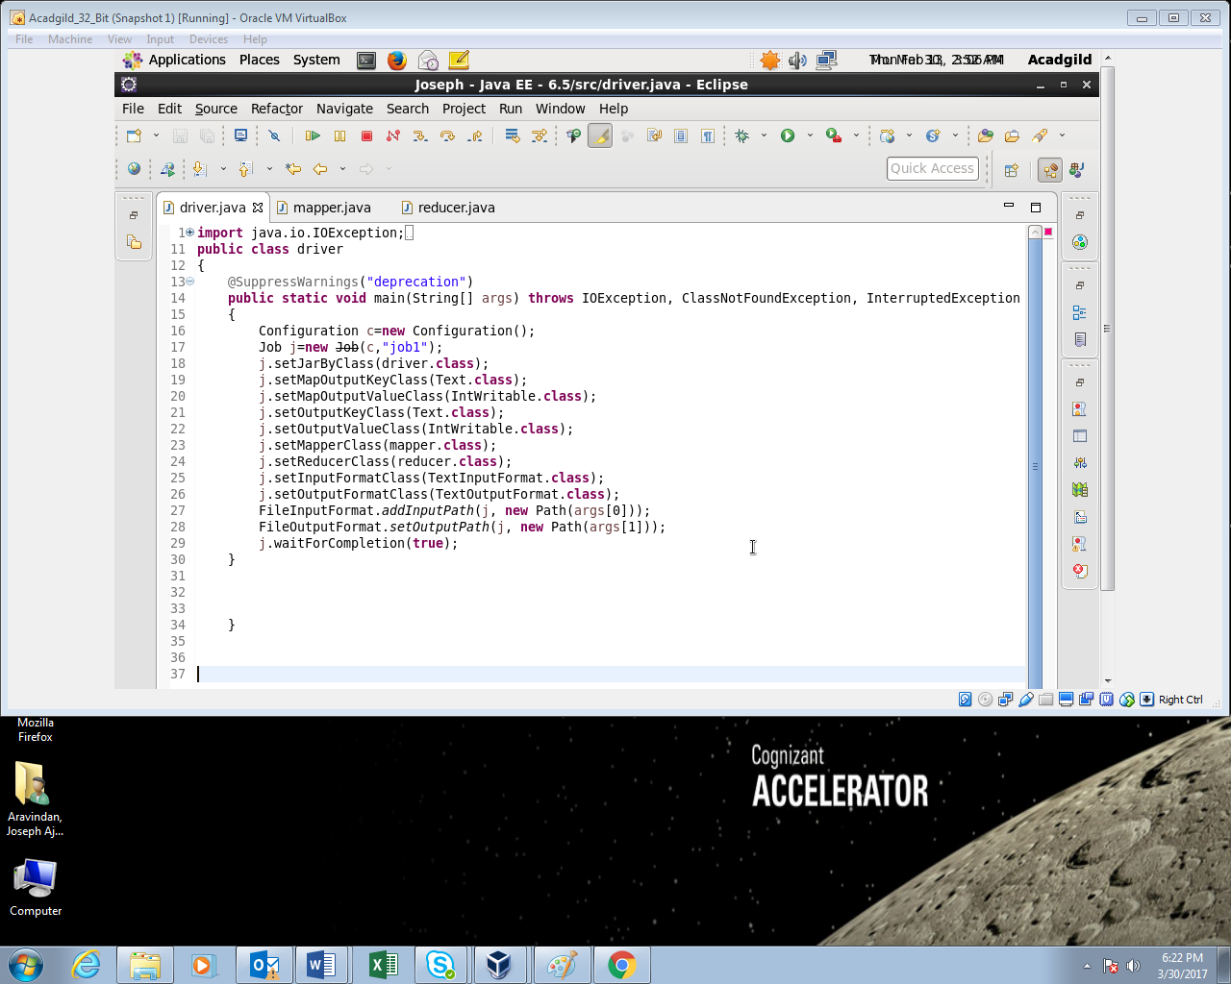

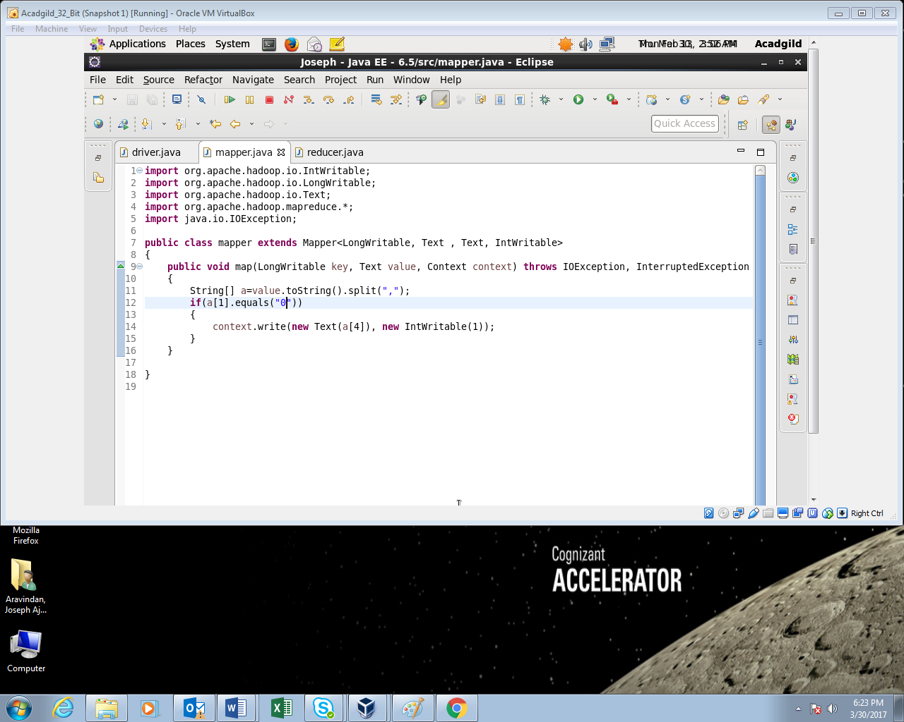

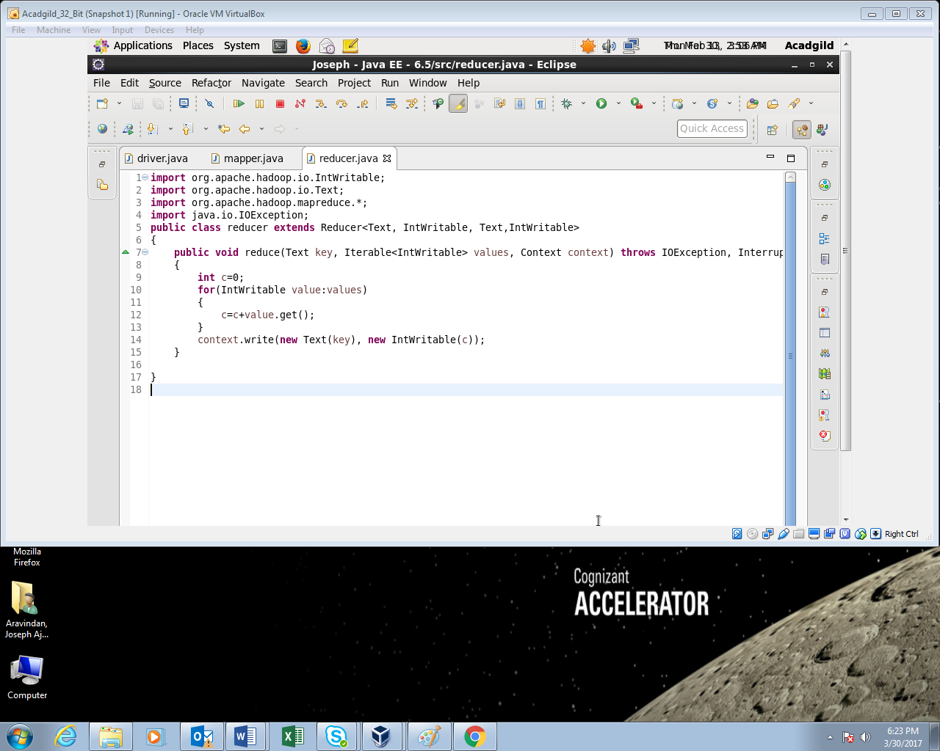

**Output:**

